

**Shortcut registration procedure**

Revision history

|  |  |  |
| --- | --- | --- |
| Version | date | memo |
| 1.0 | 2015.06.30 | Issue 1st edition |
| 2.0 | 2017.09.07 | Modified for distribution with Open API SDK |

１. Outline

You can register shortcuts on the home screen and CNC screens using the Application Selector. This manual shows the procedure how to register shortcut icons.

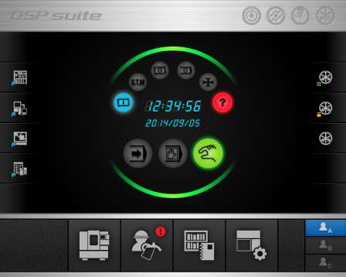

**Shortcut**

### HOME screen

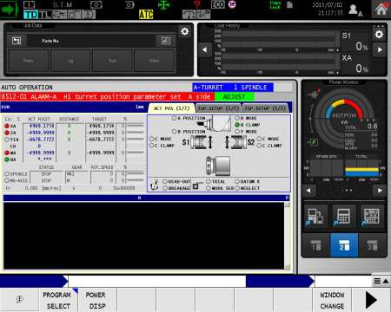

**Shortcut**

**CNC SCREEN**

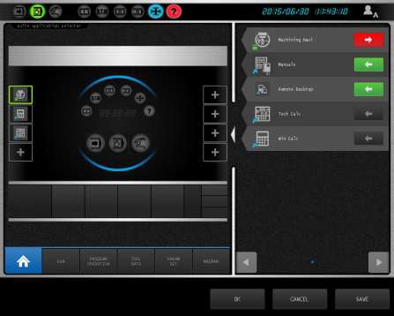

**Shortcut list**

**Application selector (HOME)**

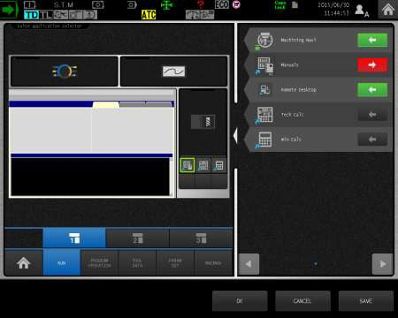

**Shortcut list**

**Application selector (CNC screen)**

**2. Shortcut registration procedure**

# The following procedure enables you to add your own shortcuts in OSP suite.

2-1 Property information file

## Each shortcut requires a property information file in order to be registered

Property information file : ***“*property.xml*”***

- Detail information for each tag : refer to chart 2-1.

- Description example : refer to chart 2-2

Chart 2-1 shortcut property information

|  |  |  |  |  |
| --- | --- | --- | --- | --- |
| **TAG** | **Items** | **data** | **Required or Optional** (※8) | **Note** |
| <shortcutInfo> | Shortcut information | － | **Required** |  |
| <version> | Version | 0.0.0.1 | **Required** | The version of Shortcut information |
| <location> | Shortcut assign location | 8 | **Required** | ※Fixed value |
| <widgetGroup> | Widget Group | 1 ～ 15 | **Required** | 15 : fixed |
| <dispOpeMode> | Operation mode | 1 ～ 63 | **Required** | Set the mode of operation that can be placed a shortcut.  Set the logical sum for specified as follow.  1：Home screen 2：Run display 4：Program edit 8：Tool data setting 16: Parameter setting 32：MacMan  (※9) |
| <maxNum> | Maximum setting number | 1 | Optional | 1 : fixed |
| <machine> | Machine type | L、M、G、A | **Required** | Machine type(※3)  L: OSP-P300S(LP)/L  M: OSP-P300S(MP)/M  G: OSP-P300G  A: All / Any machine type |
| <specL> | Data API for  OSP-P300S(LP)/P300L | － | Optional | Reference data API shortcuts enable / disable judgment (※4) (※5) |
| <majorIndex> | Major index | Numeric value | Optional | Major index of target data API(※4) |

|  |  |  |  |  |
| --- | --- | --- | --- | --- |
| <subScript> | Sub script | Numeric value | Optional | Subscript of target data API (※4) |
| <minorIndex> | Minor index | Numeric value | Optional | Minor index of target data API(※4) |
| <subSystem> | Sub system | Numeric value | Optional | Sub system of target data API (※4) |
| <specM> | Data API for  OSP-P300S(MP)/P300M | － | Optional | Reference data API shortcuts enable / disable judgment (※6) |
| <majorIndex> | Major index | Numeric value | Optional | Major index of target data API(※4) |
| <subScript> | Sub script | Numeric value | Optional | Subscript of target data API (※4) |
| <minorIndex> | Minor index | Numeric value | Optional | Minor index of target data API(※4) |
| <subSystem> | Sub system | Numeric value | Optional | Sub system of target data API (※4) |
| <specG> | Data API for OSP-P300G | － | Optional | Reference data API shortcuts enable / disable judgment (※7) |
| <majorIndex> | Major index | Numeric value | Optional | Major index of target data API(※4) |
| <subScript> | Sub script | Numeric value | Optional | Subscript of target data API (※4) |
| <minorIndex> | Minor index | Numeric value | Optional | Minor index of target data API(※4) |
| <subSystem> | Sub system | Numeric value | Optional | Sub system of target data API (※4) |
| <shortcutName> | Shortcut Name | － | **Required** |  |
| <CHN> | Chinese | Shortcut name | Optional | (※1) |
| <CZE> | Czech | Shortcut name | Optional | (※1) |
| <DAN> | Danish | Shortcut name | Optional | (※1) |
| <DUT> | Dutch | Shortcut name | Optional | (※1) |
| <ENG> | English | Shortcut name | **Required** |  |
| <FIN> | Finnish | Shortcut name | Optional | (※1) |
| <FRN> | French | Shortcut name | Optional | (※1) |
| <GER> | German | Shortcut name | Optional | (※1) |
| <HUN> | Hungarian | Shortcut name | Optional | (※1) |
| <ITL> | Italian | Shortcut name | Optional | (※1) |
| <JPN> | Japanese | Shortcut name | Optional | (※1) |
| <POL> | Polish | Shortcut name | Optional | (※1) |
| <PRT> | Portuguese | Shortcut name | Optional | (※1) |
| <RON> | Romanian | Shortcut name | Optional | (※1) |
| <RUS> | Russian | Shortcut name | Optional | (※1) |
| <SPN> | Spanish | Shortcut name | Optional | (※1) |
| <SWD> | Swedish | Shortcut name | Optional | (※1) |
| <TUR> | Turkish | Shortcut name | Optional | (※1) |
| <KOR> | Korean | Shortcut name | Optional | (※1) |

|  |  |  |  |  |
| --- | --- | --- | --- | --- |
| <NOR> | Norwegian | Shortcut name | Optional | (※1) |
| <TWN> | [Taiwanese](http://ejje.weblio.jp/content/Taiwanese) | Shortcut name | Optional | (※1) |
| <iconHM> | Home screen shortcut icon image | Full or relative path name | Optional | (※2)(※10)(※12) |
| <iconEX> | CNC screen short cut icon image | Full or relative path name | Optional | (※2)(※10)(※13) |
| <iconVF> | Vertical function key image | Full or relative path name | Optional | (※2)(※14) |
| <listIcon> | Selector list icon image | Full or relative path name | Optional | (※2)(※15) |
| <preview> | Selector preview image (CNC screen) | Full or relative path name | Optional | (※2)(※16) |
| <previewVF> | Selector preview image  （Vertical function key） | Full or relative path name | Optional | (※2)(※17) |
| <module> | Shortcut module file | Full or relative path name | **Required** | (※2)(※11) |

（※1）English name is essential for the shortcut name, other language names are optional.

The language except for English should not write TAG.

If the language except for English use empty TAG

(ex. <JPN/> or <JPN></JPN>), no display shortcut name on shortcut list.

Number of characters should be up to 29 characters.

（※2）Relative path comes from the following folder address.

「C:\OSP-P\LGOP\SHORTCUT\(Number+name)\(Shortcut ID)」

If there is a "\" at the beginning of the path name is treated as an absolute path.

Relative path example) <listIcon>res\listIcon.bmp</listIcon>

（※3）Multiple registration is possible by writing in a row.

Setting example for register L & M ) **<machine>LM</ machine >**

If setting value include “A”, It is determined as all machine type.

If the values set except for A/L/M/G, these are ignored.

（※4）If it is not necessary to use data API for setting display condition, it is possible to omit setting.

In case of no omit Data API set , following tag should not be omitted.

<majorIndex>< subScript >< minorIndex >< subSystem >

But in case of TAG<majorIndex> set “0”, decision of valid or invalid of Data API is not performed.

（※5）If tag <machine> is not “A” or “L”, this tag setting is ignored.

（※6）if tag <machine> is not “A” or “M”, this tag setting is ignored.

（※7）if tag <machine> is not “A” or “G”, this tag setting is ignored.

（※8）If any “Required” tag is not set; the shortcut icon is not displayed on the shortcut list.

（※9）”5-Axis Auto Tuning System” and “Machining NAVI” icons can only be assigned on the HOME screen and Run display, setting should be “3”.

If no need to put a limit on assigning by operation mode, set “63”.

（※10）It is possible to set the same image files to TAG<iconHM> and TAG<iconEX>.

（※11）If there is no module in the specified path in the <module> tag, it does not appear in the selector shortcut list.

（※12）HOME Screen shortcut icon image



HOME Screen shortcut icon

（※13）CNC Screen shortcut icon image



CNC Screen shortcut icon

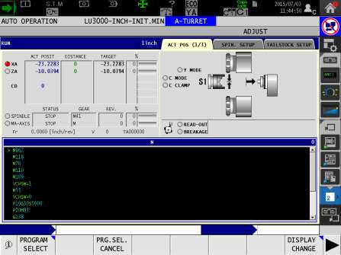

Vertical function key icon image

（※15）Application list of selector icon image

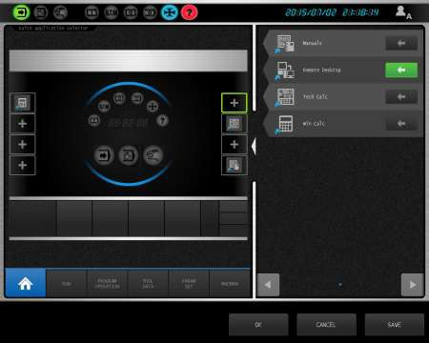

Application list of selector icon image

（※16）Preview image of selector icon image (CNC screen)

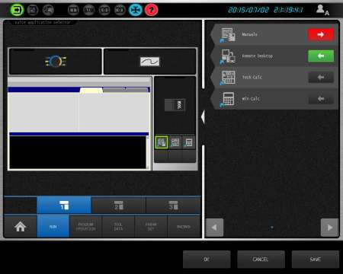

Preview image of selector icon image (CNC screen)

（※17）Preview image of selector icon image (Vertical function key）

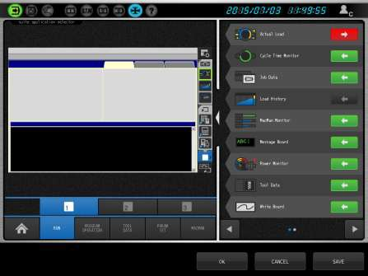

Preview image of selector icon image (Vertical function key）

Chart 2-2: Example of property information file

<?xml version="1.0" encoding="UTF-8" standalone="no"?>

<shortcutInfo>

<version>0.0.0.1</version>

<location>8</location>

<widgetGroup>15</widgetGroup>

<dispOpeMode>63</dispOpeMode>

<maxNum>1</maxNum>

<machine>A</machine>

<specL>

<majorIndex>1838</majorIndex>

<subScript>0</subScript>

<minorIndex>0</minorIndex>

<subSystem>0</subSystem>

</specL>

<specM>

<majorIndex>4</majorIndex>

<subScript>24</subScript>

<minorIndex>4</minorIndex>

<subSystem>0</subSystem>

</specM>

<shortcutName>

<ENG>Machining Navi</ENG>

<JPN>加工ナビ</JPN>

</shortcutName>

<iconHM>res\iconHM.bmp</iconHM>

<iconEX>res\iconHM.bmp</iconEX>

<iconVF>res\iconVF.bmp</iconVF>

<listIcon>res\listIcon.bmp</listIcon>

<preview>res\preview.bmp</preview>

<previewVF>res\previewVF.bmp</previewVF>

<module>C:\OSP-P\TOOLS\SVCADVICE\MI-VIS.EXE</module>

</shortcutInfo>

Shortcut information

Version of shortcut information Assign location of shortcut Widget group

Operation mode

Number of maximum set Machine type

Data API for OSP-P300S (LP)/P300L

Major index Sub script Minor index Sub system

Data API for OSP-P300S (MP)/P300M

Major index Sub script Minor index Sub system

The name of Shortcut

English name

Japanese name

HOME screen shortcut icon file

CNC screen shortcut icon file

Vertical function key icon file

Selector list icon file

Selector preview icon

(CNC) Selector preview icon

(VF-key) Module file for shortcut



# 2-2. Create folder for shortcut

Shortcut folder (”C:\OSP-P\LGOP\SHORTCUT” ）

- Create this folder and store necessary files.

Chart 0-1 Configuration of shortcut folder& files (example “calculator”)



|  |  |  |
| --- | --- | --- |
| **Folders & files** | **Required or Optional** | **Contents** |
| SHORTCUT | ***－*** | Registration folder for shortcut（” C:\OSP-P\LGOP\SHORTCUT” ） |
| 006-MACHINING-NAVI | **Required** | Folder for shortcut  ・ Add "Company name (ACME, etc.) - "the beginning of the folder name. Subsequent characters are free. (※1) |
| 00000006 | **Required** | Second folder of shortcut  ・Folder name is optional |
| property.xml | **Required** | Property information file (※2)  →please refer “ 2-1 Making of the property information file |
| res | Optional (※2) | Resource file |
| iconHM.bmp | Optional (※2) | Home screen shortcut icon image file (※3)(※4)  ・Image size：69(W)×69(H)pixel |
| iconEX.bmp | Optional (※2) | CNC screen shortcut icon image file (※3)(※4)  ・Image size：69(W)×69(H) pixel |
| iconVF.bmp | Optional (※2) | Vertical function key icon image file (※3)  ・Image size：47(W)×43(H) pixel |
| listIcon.bmp | Optional (※2) | Selector application list icon image file (※3)  ・Image size：60(W)×60(H) pixel |
| preview.bmp | Optional (※2) | Selector preview image icon files (CNC screen）(※3)  ・Image size：47(W)×47(H) pixel |
| previewVF.bmp | Optional (※2) | Selector preview image icon files (Vertical function key)(※3)  ・Image size：29(W)×29(H) pixel |

（※1）To avoid overlap of the folder names



ex) ACME case : ACME-001-APPNAME,

Okuma America Corporation case: OAC-001-APPNAMEALSO

（※2）If there is no image file description on property information file or the image file doesn’t exist,

the icon is displayed just black color.

Back ground color of image file must be Magenta (Magenta part is transparent)

（※3）As an image file, BMP and JPEG and PING can be specified.

（※4）It is possible to specified same files for [Home screen shortcut icon image file] and [CNC screen shortcut icon image file].

**3 Note**

## This is instructions when a short cut is registered into OSP suite.

3-1. Attention at the time of the installation of the OSP system DVD:

When OSP system DVD is re-installed, it is necessary to register a short cut again.